Gỉa sử URL = localhost:4200.

* Localhost:4200/book-store: Trang bán sách, mượn sách như Tiki.
* Localhost:4200/admin/Login: Trang đăng nhập cho ADMIN.
* Localhost:4200/admin/User-management
  + Localhost:4200/admin/User-management/User-list
  + Localhost:4200/admin/User-management/User-detail/{id}
  + Localhost:4200/admin/User-management/create-user
* Localhost:4200/admin/Books-management
  + Localhost:4200/admin/Books-management/book-sell
    - Localhost:4200/admin/Books-management/book-sell/book-list
    - Localhost:4200/admin/Books-management/book-sell/book-detail
  + Localhost:4200/admin/Books-management/book-borrow
    - Localhost:4200/admin/Books-management/book-borrow/book-list
    - Localhost:4200/admin/Books-management/book-borrow/book-detail
* Localhost:4200/admin/CategoryBooks-management
  + Localhost:4200/admin/CategoryBooks-management/book-list
* Localhost:4200/admin/Borrow-management
  + Localhost:4200/admin/Borrow-management/book-list
  + Localhost:4200/admin/Borrow-management/create-borrowticket
  + Localhost:4200/admin/Borrow-management/tab-acception
  + Localhost:4200/admin/Borrow-management/finish-borrowticket
* Localhost:4200/admin/Supplier-management
  + Localhost:4200/admin/Supplier-management/supplier-list
  + Localhost:4200/admin/Supplier-management/create-supplier
* Localhost:4200/admin/Statistics-management
  + Localhost:4200/admin/Statistics-management/tab-borrowbook
  + Localhost:4200/admin/Statistics-management/tab-sellbook
* Localhost:4200/admin/Booksell-Management
  + Localhost:4200/admin/Booksell-Management/check-in
  + Localhost:4200/admin/Booksell-Management/check-list
  + Localhost:4200/admin/Booksell-Management/check-detail/{id}
  + Localhost:4200/admin/Booksell-Management/check-out
  + Localhost:4200/admin/Booksell-Management/cash
* Localhost:4200/admin/Setting
* Localhost:4200/admin/Gift
* Localhost:4200/admin-manager/inventory-managenment
  + Localhost:4200/admin-manager/inventory-managenment/ inventory -list (type: nhập hay xuất kho)
  + Localhost:4200/admin-manager/inventory-managenment/inventory -detail/{id}
  + Localhost:4200/admin-manager/inventory-managenment/inventory-receiving-create
  + Localhost:4200/admin-manager/inventory-managenment/inventory -delivery-create
  + Localhost:4200/admin-manager/inventory-managenment/inventory-create
* Localhost:4200/admin-manager/Admin-management
  + Localhost:4200/admin-manager/Admin-management/admin-list
  + Localhost:4200/admin-manager/Admin-management/admin-detail
* Localhost:4200/admin-manager/schedule-manegement
  + Localhost:4200/admin-manager/schedule-manegement/schedule -list
  + Localhost:4200/admin-manager/schedule-manegement/schedule-currence
* Localhost:4200/user/login: Trang đăng nhập cho user (Khi đăng nhập thành công, chuyển view về Trang bán sách ở trên).
* Localhost:4200/user/register: Trang đăng ký cho user.(user đăng ký).
* Localhost:4200/user/settings: Trang cập nhật thông tin tài khoản.
* Localhost:4200/book-store/product-detail/{productId}: Trang thông tin chi tiết của sản phẩm.
* Localhost:4200/book-store/checkout/cart-borrow: y chang hình dưới nhưng ko có tiền Thanh toán.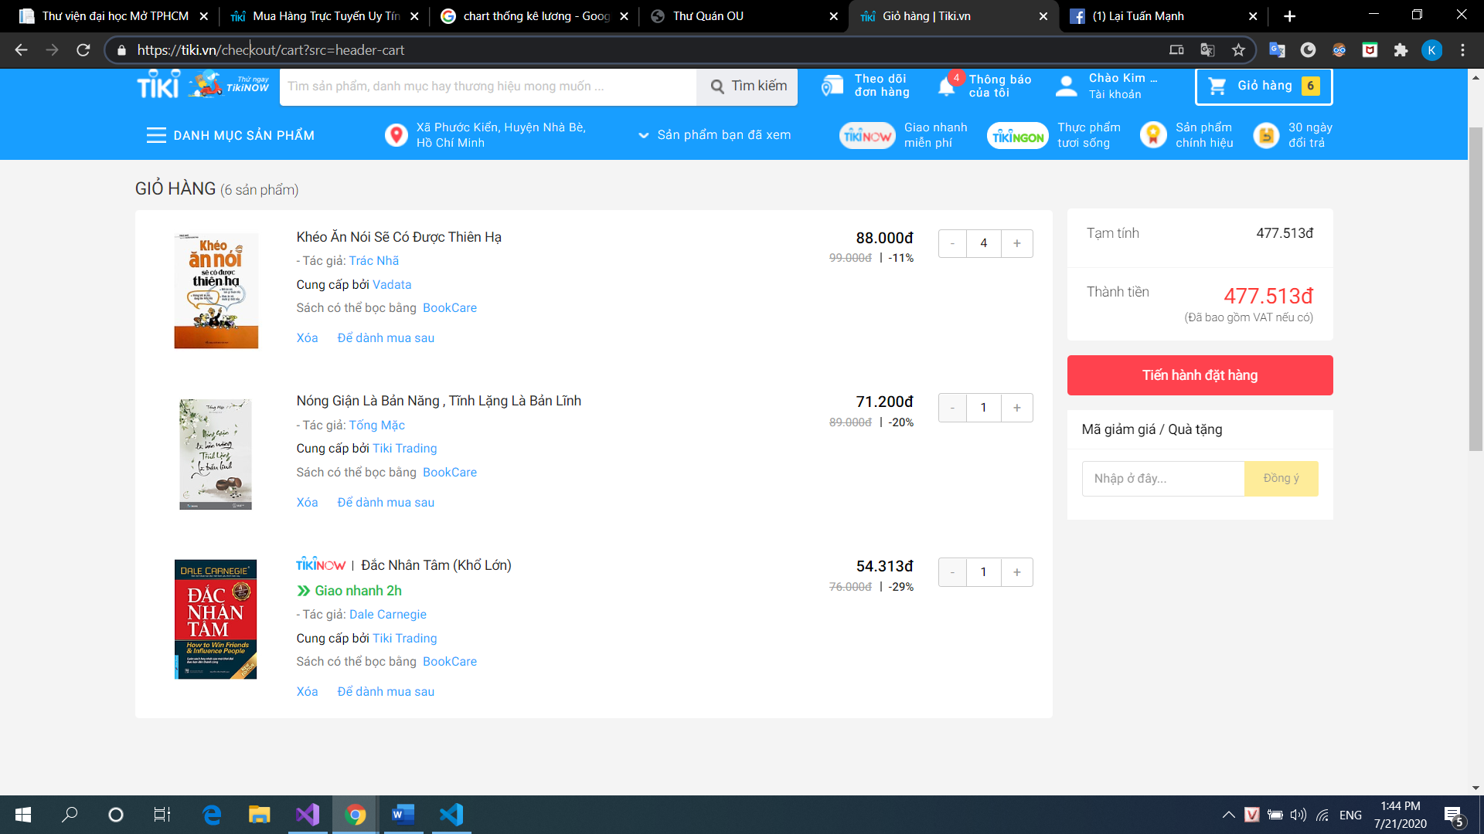 => Khi click mượn, hiện confirm popup “Bạn có xác định mượn chứ ?”=> Thành công thì thông báo “Bạn đang nằm trong danh sách chờ admin xác nhận.” => Thành công => chuyển qua order-detail với status == WC (waiting confirm). Nếu Admin xác nhận => status == B . Nếu Admin từ chối => status = **FB**
* Localhost:4200/book-store/checkout/cart-sell: 
* Localhost:4200/book-store/checkout/shipping: 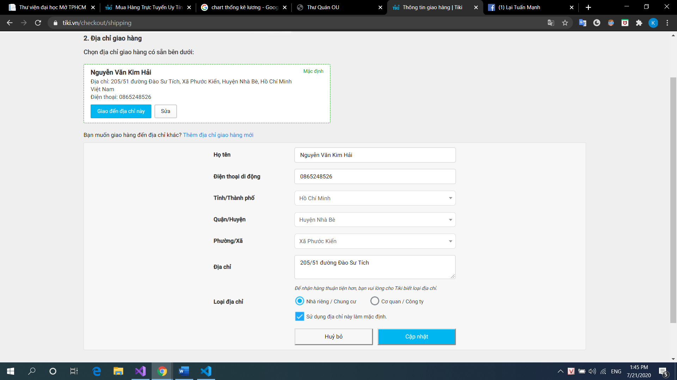

• Localhost:4200/book-store/checkout/payment: 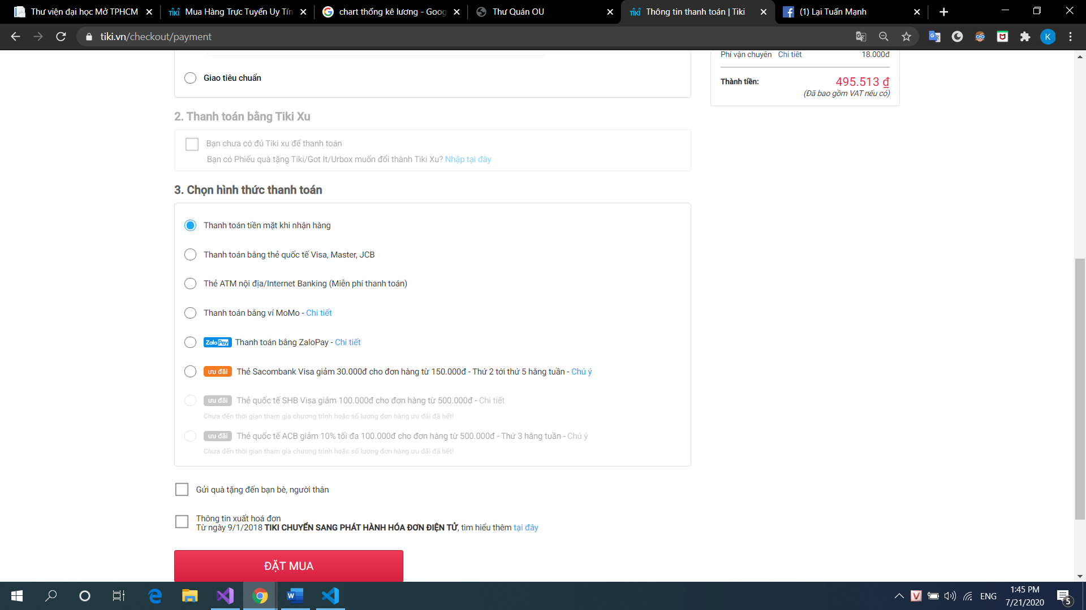 => Nếu đặt mua thành công, toastr thông báo đặt thành công => chuyển về trang Chi tiết đơn hàng đó.